Here is a step-by-step guide to completing the assignment:

**Installation Steps:**

1. **Install Java Development Kit (JDK):**

* Download and install the latest version of JDK from the official Oracle website.

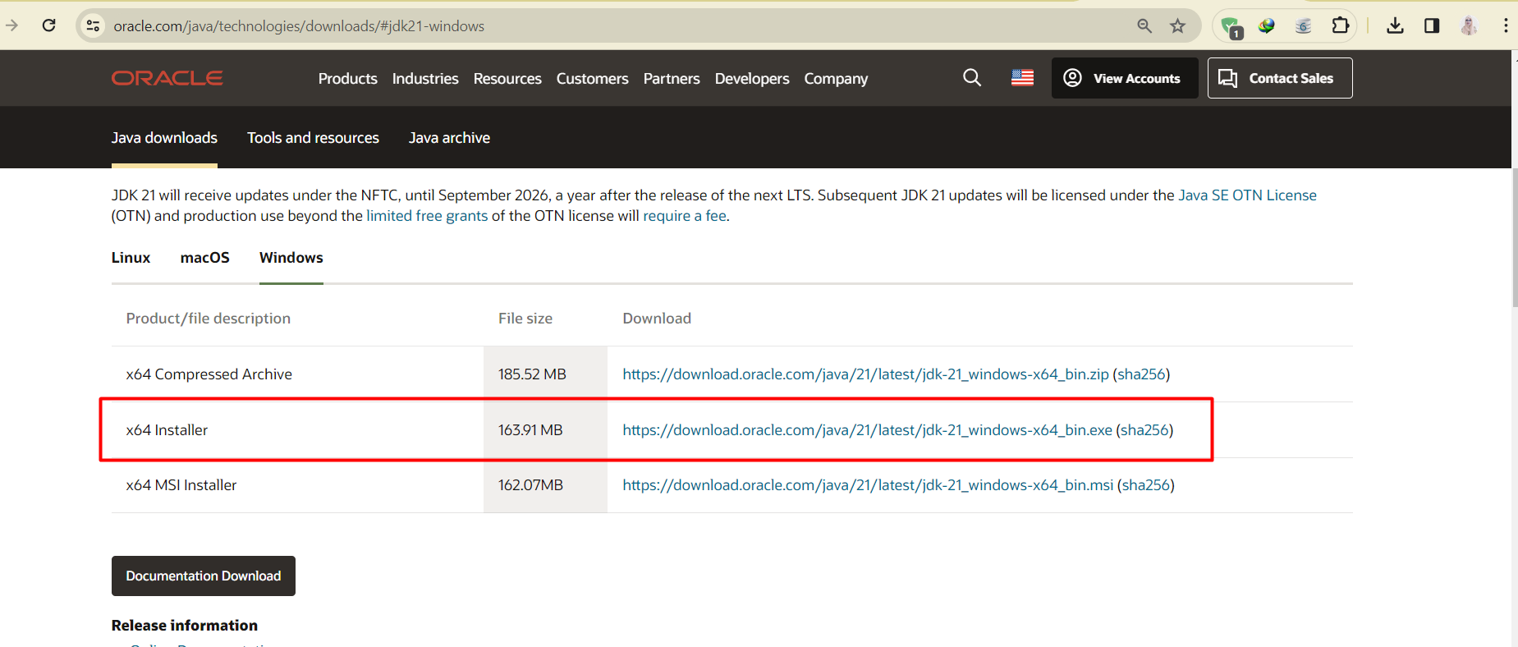

1. **Set up environment variables:**

* After installing the JDK, I need to set up the JAVA_HOME and PATH environment variables. First for that resonance, I open the Control Panel on my Windows system.
* Search for "Edit system environment variables".
* In the Environment Variables window, under System Variables, click "New" to create a new variable and set the variable name to JAVA_HOME.
* Set the variable value to where the JDK is installed (C:\Program Files\Java\jdk-21).
* Click "OK" to save the variable.
* After that, find the "Path" variable under System Variables and click "Edit" in it to change the path variable. (C:\Program Files\Java\jdk-21)
* To verify the Java installation, go to the command prompt and enter java --version. This command will display the Java version installed on my system.

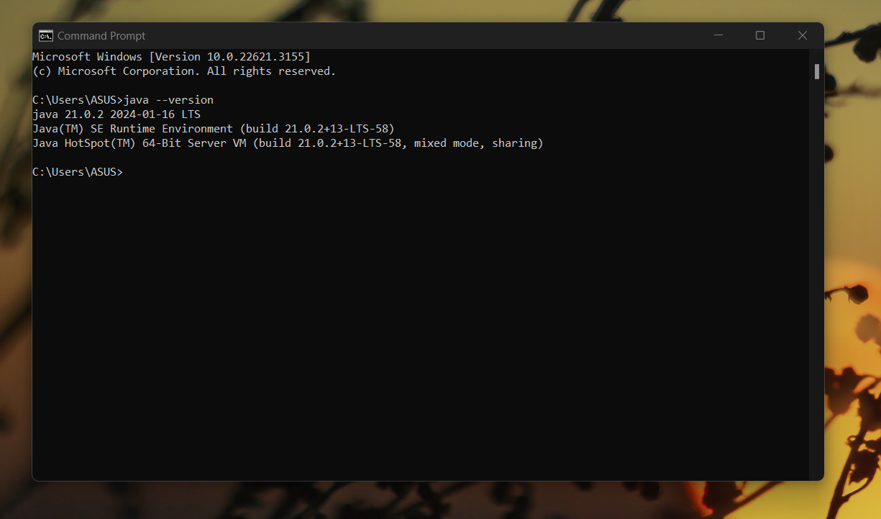

1. **Install Selenium WebDriver:**

* Downloaded Selenium Java driver from official Selenium website.

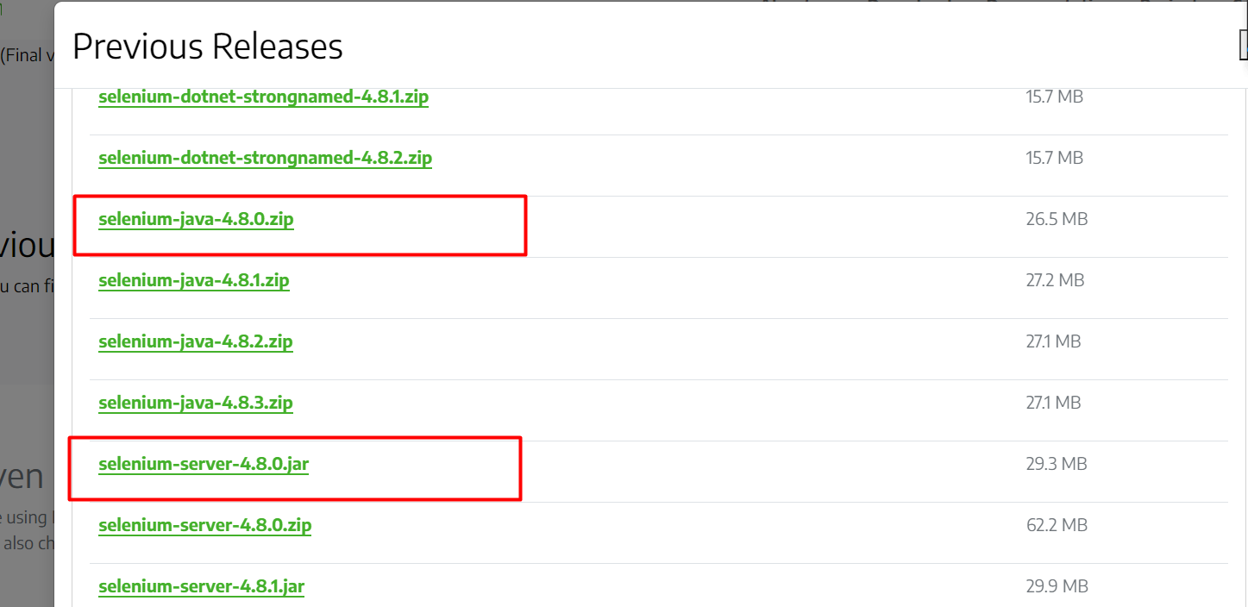

1. **Check Chrome Version:**

* First, check my current Chrome browser version. Open Chrome and click on the three vertical dots in the top-right corner. Go to "Setting" then “About Google Chrome.”

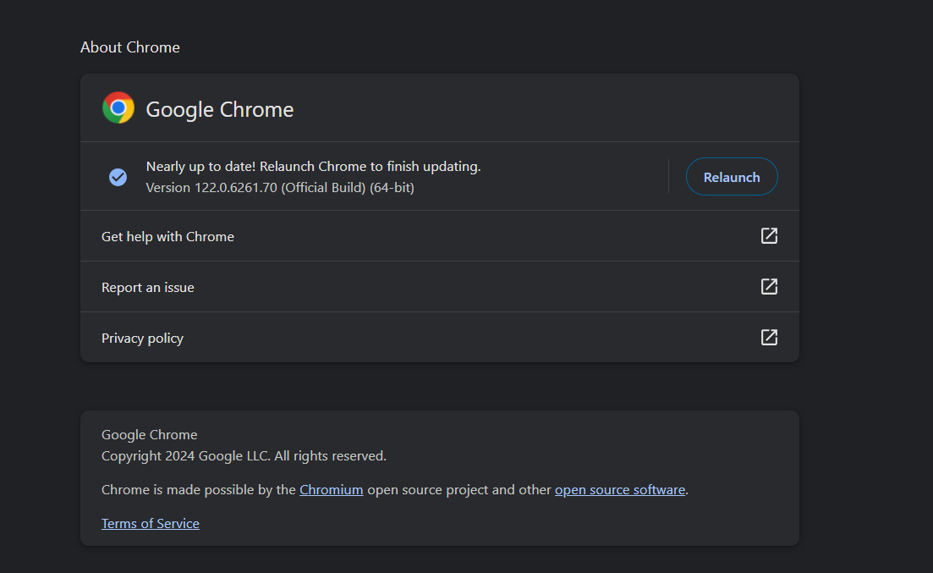

* Download ChromeDriver for my version (Version 122.0.6261.70). Click on the link to download the ChromeDriver ZIP file ( chromedriver_win64.zip) then extract ChromeDriver.

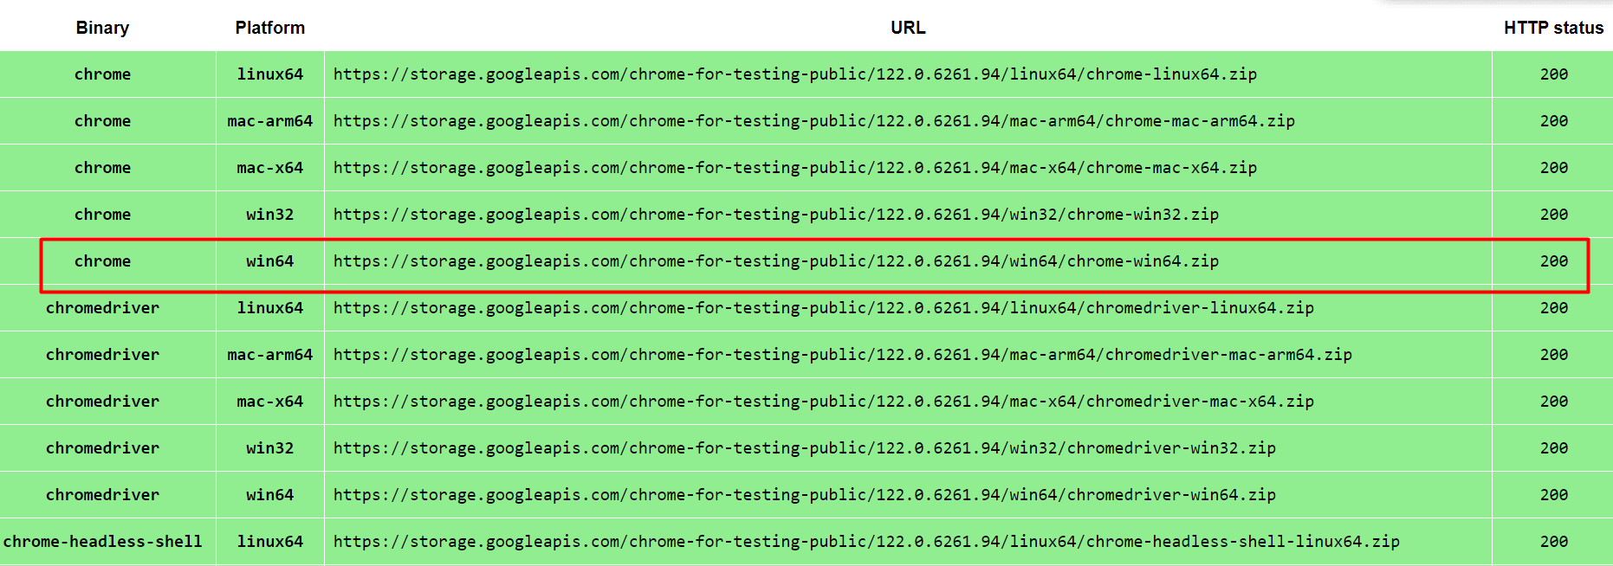

1. **Install the Eclipse IDE:**

* Download and install Eclipse IDE for Java developers.

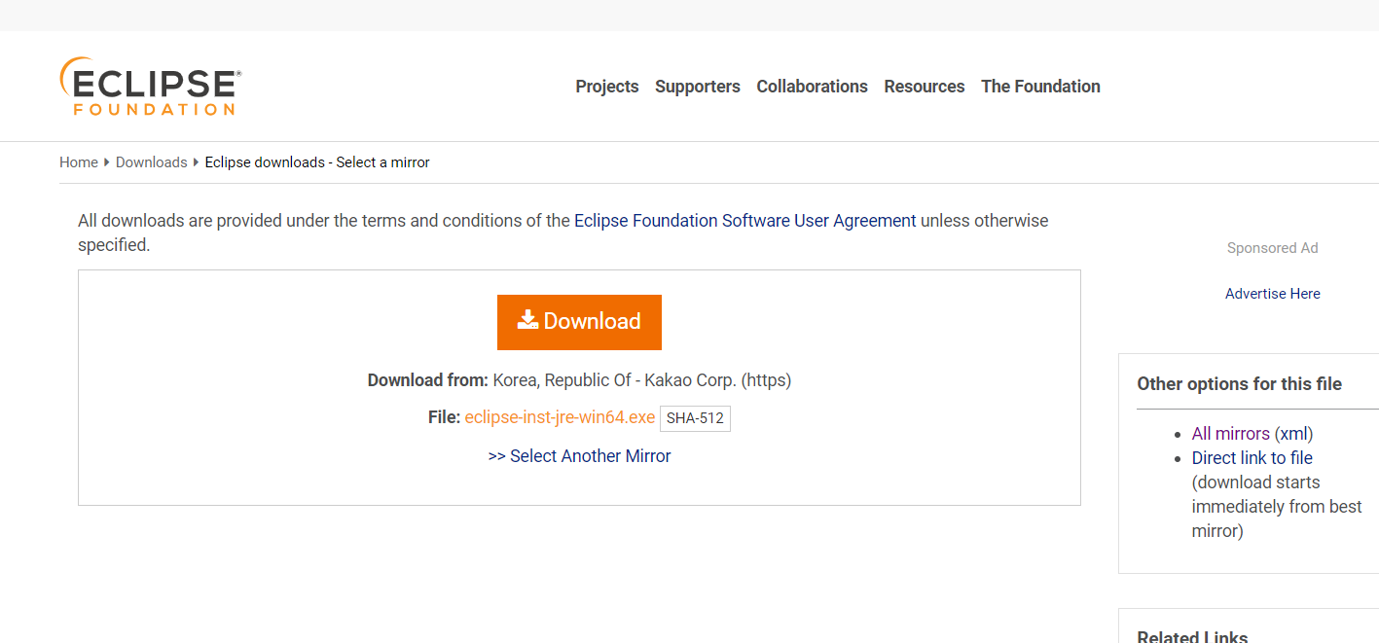

* Start Eclipse and create a new workspace.
* Select "File" > "New" > "Java Project".
* Set project name and click “Finish”. (Project name: OstadDay1)
* click “src” > “New” > “Package”.
* Set package name and click “Finish”. (Package name: Web)
* click “src “> “New” > “Class”
* Set class name and click “Finish”. (Class name: Test)
* Right-click on your project in the "Package Explorer" pane.
* Select "Build Path" > "Configure Build Path".
* Click on the "Libraries" tab.
* Click on the "classpath".
* Click "Add External JARs".
* Navigate to the directory where stored the Selenium JAR files.
* Select all the Selenium JAR files and click "Open".
* Click "Apply and Close" to save the changes.
* Open the "lib" folder.
* Select all the JAR files inside the "lib" folder and click "Open".
* Click "Apply and Close" to save the changes.
* Select all and save all files in your Eclipse project.
* Expand the "Referenced Libraries" section to ensure that all the necessary JAR files are listed there.

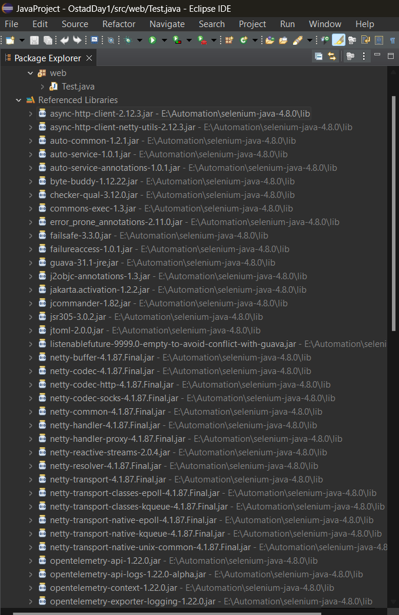

1. Code Run:

* After run the run code.

